

KISII SCHOOL 2025 PREDICTION
(KCSE PRE-ANALYSIS TEST)
121/2
MATHEMATICS
PAPER 2
TIME: 2½ HOURS

NAME……………………………………………………………………………………….
SCHOOL……………………………………………… SIGN………………………..
INDEX NO……………………………………………. ADM NO……………………

(Kenya Certificate of Secondary Education)

INSTRUCTIONS TO CANDIDATES
- Write your name, index number and class in the spaces provided above.
- The paper contains two sections: Section I and Section II.
- Answer ALL the questions in Section I and ANY FIVE questions from Section II.
- All working and answers must be written on the question paper in the spaces provided below each question.
- Marks may be awarded for correct working even if the answer is wrong.
- Negligent and slovenly work will be penalized.
- Non-programmable silent electronic calculators and mathematical tables are allowed for use.

For examiners use only
Section I
1 | 2 | 3 | 4 | 5 | 6 | 7 | 8 | 9 | 10 | 11 | 12 | 13 | 14 | 15 | 16 | Total

Section II
17 | 18 | 19 | 20 | 21 | 22 | 23 | 24 | Total
Grand
Total

Section a (50marks)
Answer All Questions in this section
1. The area of a rectangle is 48.4cm² and its length is 9.37cm. Calculate the percentage error in width (3marks)

2. The base of a triangle is cm. The height of the triangle is 5cm shorter than its base. Given that the area of the triangle is 25cm². Find length of the base. (4marks)

3. Find the area of the triangle shown below (3marks)
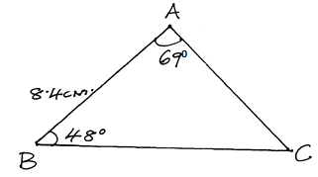

4. Express the following expression in surd form and simplify by rationalising the denominator
(3marks)

5. Solve for x in the expression (3marks)

6. The table below is part of the tax for monthly income for the year 2007
Monthly income (ksh) | Rate %
Under ksh 10165 | 10
From 10165 but under ksh19741 | 15
From 19741 but under ksh29317 | 20
In that year, John’s monthly gross tax was Ksh 2885. Calculate his monthly income (3marks)

7. A quantity E is partly constant and partly variaes as square root of F.
i) Write down an equation connecting E and F where K and C are constants respectively.

ii) If F=25 where E=22 and F=49 when E=28. Find the value of K and C (3marks)

8.a)Expand in ascending power of x (1mark)

b) Using the first four times of the expansion in (a) above estimate the value of (2marks)

9. Find the number of terms of the series 5+8+11+14+17+……….. that will give a sum of 2183 (3marks)

10.Find the inverse of the matrix hence find the co-ordinates of the point at which line intersect (3marks)

11.A trader mixed grade I, II and III of coffee in the ratio 2:3:5 respectively. Grade I cost Sh650 per kg, grade II costs sh 500 per kg and grade III costs sh 420 per kg.
a) Find the cost of one kg of the mixture (2marks)

b) If the trader sold the mixture at a profit of 20% calculate the selling price of 3kg of the mixture (2marks)

12. Solve for the equation for (3marks)

13.The figure below has a cross-section of the prism which is an isosceles triangle of side AE= 8cm, DE= 8cm and AD=6cm, where AB=20cm
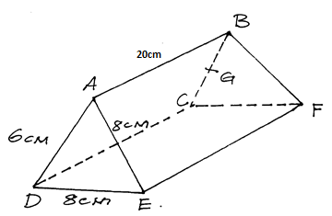

a) If G is the mid- point of side BC find
i) GF (1mark)

ii) AG (1mark)

b) The angle between line DF and plane ABCD (2marks)

14.a) Construct triangle PQR in which PQ=QR=5cm and angle PQR=90º (2marks)
b) Draw the locus of S which moves in such a way that it is always on the same side of PR as Q and angle (1mark)

15. Determine the amplitude and period in the function (2marks)

16.Two towns P and Q are located on the equator such that P is due east of Q. The distance between the two towns is 1920nm. If the latitude of p is 50ºE. Determine the longitude of Q (3marks)

Section b (50 marks)
Answer any five questions from this section
17.The cost of Jane’s car at the beginning of year 2000 was sh 750,000. It depreciated in value by 7% per year for the first 3 years, by 8% for the next two years and 11% per year for the subsequent years.
a) Find the value of the car at
i) The start of the year 2003 (2marks)

ii) The end of year 2007 (3marks)

b) At the beginning of 2008, Jane sold the car through Mary,s dealers at 22% more than its actual depreciated value to Lucy. Taking Mary’s sale price as the car’s value after depreciation. Find the average monthly rate of depreciation for the 8years. (5marks)

18. MNP is a triangle with vertices M,(2,2),N(2,-2) and P(-1,-4). Draw the triangle MNP. (1mark)

a) If vertex N(2,-2) is mapped to N¹ (5,-2) by a shear with x-axis invariant, draw triangle M¹N¹P¹, the image of triangle MNP under the shear. (2marks)
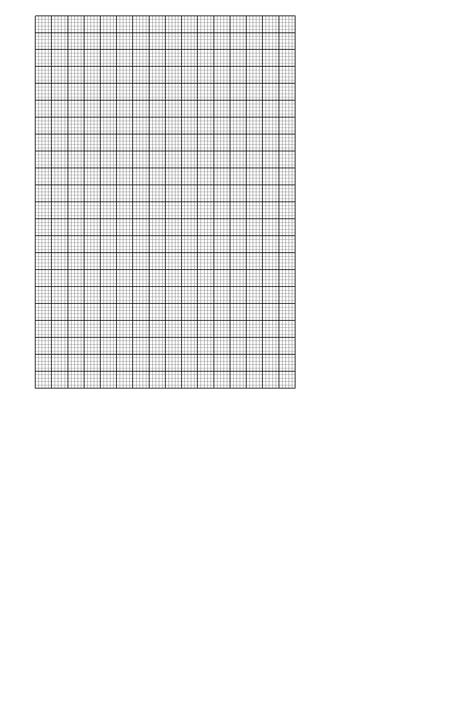

b) Find the matrix that represent the shear in (a) above (2marks)

c) A transformation where matrix is maps triangle M¹N¹P¹ onto M¹¹N¹¹P¹¹. Draw the triangle M¹¹N¹¹P¹¹ (3marks)

d) Describe fully a single transformation that maps triangle M¹¹N¹¹P¹¹ back onto triangle MNP and give its transformation matrix. (2marks)

19. Complete the table below for the equation (2marks)
x | -3 | -2 | -1 | 0 | 1 | 2 | 3 | 4 | 5
y | -32 |  | 8 | 7 | 0 |  | -8 |  | 32

b) Draw the graph of (3marks)



c) Use your graph to estimate the roots of the equation (2marks)

d) Use your graph to solve the equation (3marks)

20. The table below shows marks scored by 40 students in a test
Marks | 11-20 | 21-30 | 31-40 | 41-50 | 51-60 | 61-70 | 71-80 | 81-90
frequency | 1 | 5 | 8 | 12 | 7 | 4 | 2 | 1
a) Calculate the upper quartile and lower quartile (4marks)

b) If 30% of students failed the test, find the pass mark (3marks)

c) The pass mark was set at 25 marks. How many students passed the test. (3marks)

21.)The diagram below shows two intersecting circles with centres X and Y. HG is a tangent to the circle centre X at C. Angle GCE=70º and angle CEF=130º. Given that CB=5cm, BA=4cm, AE=12cm and radius DY=6cm.
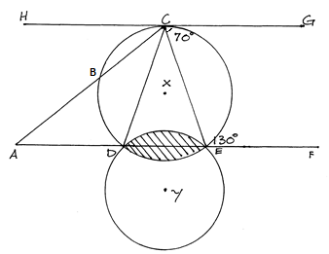
a) Determine
i) Angle DXE (2marks)

ii) Length DE (2marks)

iii) Angle DYE (2marks)

b) Calculate the area of the shaded region (take ) (4marks)

22.a) Wekesa has two fair tetrahedral solids one red and other green. The faces of red solid are numbered 1to 4 while the faces of green solid are numbered 2,3,5 and 6. He tosses the two solids at the same time and recorded the number that is the bottom face of each solid. If k is the number that is at the bottom face of red solid while t is the number that is at the bottom face of green solid, find the probability that
i) 2k+t=7 (1mark)

ii) (2k+t) is at most 9 (1mark)

iii) (2marks)

b) In a group of 40 people, 10 are healthy and every person of the remaining 30 has either high blood pressure, a high level of cholesterol or both. Given that 15 have high blood pressure, 25 have high level of cholesterol and x have both. If a person is selected at random from this group. What is the probability that he/ she
i) Has high pressure only (2marks)

ii) Has high level of cholesterol only (1mark)

iii) Hass high blood pressure and high level of cholesterol (1mark)

iv) Has either high blood pressure or high level of cholesterol (2marks)

23.A company was contracted to transport 1200 tonnes of sand. The company used type A and type B trucks to do the job. Each type A truck carries 10 tonnes of sand per trip while B curries 15 tonnes per trip. The total number of trips must not be less than 70 and type B truck must make at least twice as many trips as type A truck while the later must make not less than 10trips. Taking x to represent the number of trips made by type A trucks and y to represent the number of trips made by type B trucks
a) Write down all the inequalities representing the above information (4marks)

b) Represent the inequality graphically (4marks)

c) The company makes a profit of sh2000 per trip made by each type A truck and sh 3000 per trip made by each type B truck.
i) Using a search line, determine the number of trips each type of truck must be made to maximise the profit (1mark)

ii) Hence calculate the maximum profit (1mark)

24.a) Find the area of the region bounded by the cuver and the axes between the point x=-1 and x=1 (4 marks)

b) At a certain instant a body is moving in a straight line at 20cm/s. Its acceleration during the first 5seconds of the subsequent motion is (30-6t) cm/s² where t is the time in seconds. After 5 seconds it travels with a constant speed. Find
i) Its velocity after 2seconds (2marks)

ii) The greatest velocity attained (2marks)

iii) The distance travelled in 10 seconds (2marks)

THIS IS THE LAST PRINTED PAGE

